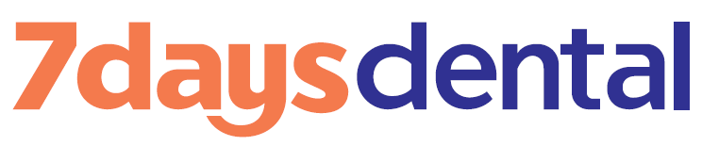
Patient Acknowledgement: COVID-19 Pandemic Dental Treatment Risk

Please read the patient acknowledgement below, and initial or sign in all areas indicated.

Patient Name:

I understand the novel coronavirus causes, the disease known as COVID-19, and that it is currently a pandemic. I understand the novel coronavirus virus has a long incubation period during which carriers of the virus may not show symptoms and still be contagious. For this reason, I understand that the federal and provincial authorities have it is recommended that Ontarians stay home and avoid close contact with other people when at all possible.
(initial)

I understand the federal and provincial authorities have asked individuals to maintain social distancing of at least two (2) meters (or six (6) feet) and I recognise it is not possible to maintain this distance while receiving dental treatment. (initial)

I understand that oral surgery/dental procedures can create water and/or blood spray, which is one important way that the novel coronavirus can spread. The ultra-fine nature of the spray can linger in the air for minutes to sometimes hours, which can transmit the novel coronavirus.
(initial)

I understand that due to the visits of other patients, the characteristics of the novel coronavirus and the characteristics of dental procedures, that I have an elevated risk of contracting AND SPREADING the novel coronavirus simply by being in the dental office. (initial)

I agree to complete a COVID-19 screening questionnaire as required by the Ministry of Health.
(initial)

I confirm that I am not waiting for the results of a test for COVID-19. (initial)

If I received COVID-19 test results in the past three (3) months, the last results I received were negative. (initial) If applicable, approximate date of test:
(If not applicable, please initial and write “N/A” in the blank space provided)

I confirm that this is not currently a period during which public health authorities required I self-isolate for 14 days. (initial)

I verify the information I have provided on this form is truthful and accurate. I knowingly and willingly consent to have dental treatment during the COVID-19 pandemic.

SIGNATURE OF PATIENT: Date:
(or signature of parent/guardian for patients under 18 years of age)

Please print this page and bring it to your appointment, or email to info@7daysdental.ca.

